DS.140 Integration Design Specification



Supplier PO type DFF Integration

Author: Nidhi Siotia

Creation Date: Jun 21, 2023

Last Updated: Jun 21, 2023

Version: 1.0

**Approvals:**

|  |  |
| --- | --- |
| <Approver 1> | <Rakesh Khanna / Naushad / Amit> |
| <Approver 2> | <Business Owner> |

# Document Control

## Change Record

| Date | Author | Version | Change Reference |
| --- | --- | --- | --- |
| 21-Jun-2023 | Nidhi Siotia | 1.0 | No Previous Document |
|  |  |  |  |
|  |  |  |  |

2

## Reviewers

| Name | Position |
| --- | --- |
| FHL Business | Business User |
| FHL IT Group | Fortis IT Team |
|  |  |
|  |  |

Contents

1 Document Control ii

1.1 Change Record ii

1.2 Reviewers ii

2 Introduction 4

2.1.1 Scope for this Document 4

2.1.2 Intended Audience 4

3 Overview 5

3.1 Business Objectives 5

3.2 Major Features 5

3.3 Glossary 5

4 High-Level Fusion Integration flow 7

5 Technical Design Details 8

5.1 OIC Services 8

5.2 Fusion BIP Report 9

5.3 Oracle PaaS DBCS components 11

5.4 Technical flow 11

6 Data FIELD Mapping 12

6.1 File format 12

6.2 Frequency 12

7 Exception handling 13

7.1 Scenarios 13

8 Assumptions / Considerations 14

9 Open and Closed Issues 15

9.1 Open Issues 15

9.2 Closed Issues 15

# Introduction

### Scope for this Document

This analysis specification document is prepared to layout the design for an integration to update the supplier header level DFF along with supplier GSTIN captured in qualification section during supplier registration.

### Intended Audience

This document is intended for the following groups to provide the action items and consideration that are required to complete the implementation of the various Supply Chain and Finance related functionalities from Oracle Fusion.

#### Fortis Business Users

This document will be helpful for Fortis Business users to understand the technical design and process change with the new structure implemented in Oracle. The business user will validate this document after the verification of the requirement.

#### PwC Technical Team

The PwC technical team will use this document as a source technical design document to develop the technical solution to implement / deploy in Oracle Fusion.

#### Fortis IT Team

The Fortis IT Team must facilitate the PwC technical team for requisite details and other elements required from Business. The Fortis IT team is also responsible to arrange and provide required technical information wherever is required.

# Overview

Fortis Healthcare Limited (FHL) is a chain of hospitals, headquartered in India. Fortis started its health care operations from Mohali where first Fortis hospital was started. Later, the hospital chain purchased the healthcare branch of the Escorts group and increased its strength in various parts of the country. The Fortis health care also operates its hospital in Vasant Kunj, Faridabad, Gurgaon. The FMRI hospital at Gurgaon is the headquarter of Fortis healthcare with all the major facilities at the hospital.

This specification document is prepared to layout the design for an integration to update the supplier level DFF and GSTIN details.

## Business Objectives

The following are the business objectives.

1. To have a secure, reliable, and scalable design flow to fetch the supplier details captured during registration and update supplier level attributes.
2. To have a solution providing the monitoring capabilities.

## Major Features

The proposed solution will have the following features involved:

1. OIC integration invokes Fusion BI report to fetch the supplier registration level details for which it’s not updated at supplier record level.
2. The OIC integration then invokes a REST API to update the supplier & capture GSTIN accordingly.

## Glossary

REST

Representational State Transfer.

OIC

Oracle Integration Cloud

BIP

Business Intelligence Publisher

API

Application programming interface

ESS

Enterprise scheduler service job

DFF

Descriptive flex field

GSTIN

Goods and Services Tax Identification Number

# High-Level Fusion Integration flow

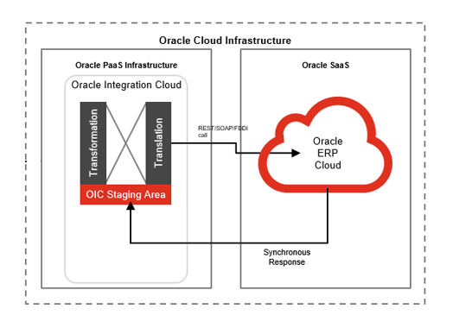

# Technical Design Details

This section describes the technical details of all the components involved in the design for an integration to update the supplier site status based on the drug license information at the Supplier DFF level.

## OIC Services

An App driven orchestration has been designed in OIC to build a REST Endpoint URL:

|  |  |
| --- | --- |
| OIC Integration Name | Fortis Update PO Type at Payable Invoices (1.0) |
| Method | POST |

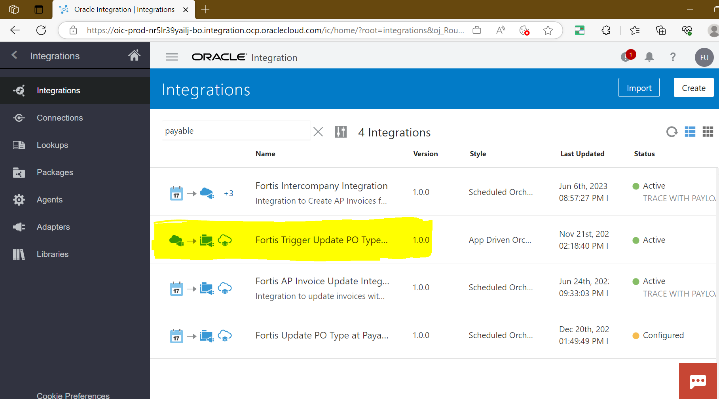

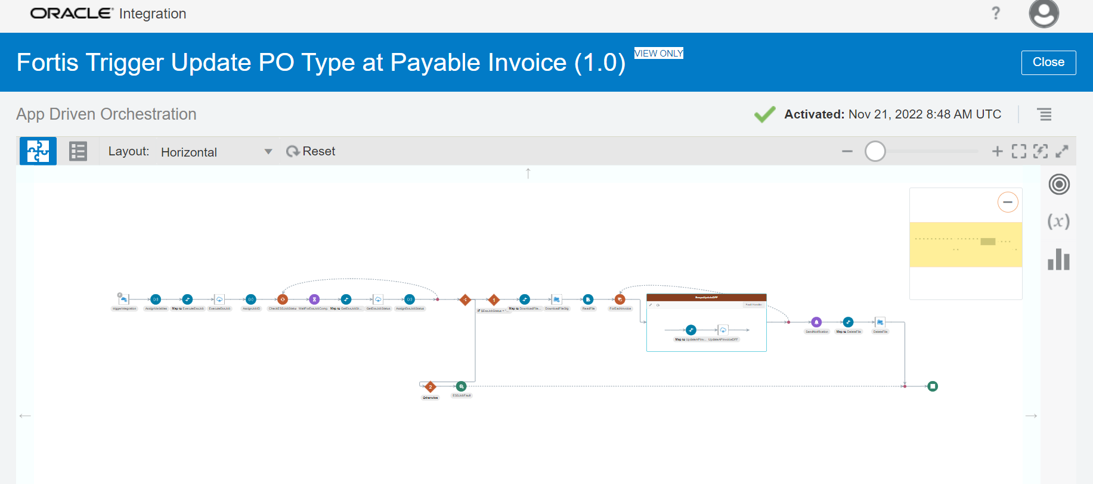

## Fusion BIP Report

|  |  |  |  |
| --- | --- | --- | --- |
| SI No | BIP Report | Data Model | Description |
| 1 | /Custom/Interfaces/Integration Reports/Payable/ Fortis Update PO Type on Invoice Report.xdo | /Custom/Interfaces/Integration Reports/Procurement/Data Model/ FORTIS_UPD_PO_TYPE_AP_INV_DM | This report is used to fetch standard invoices with line type as item and miscellaneous and for invoices for which PO TYPE is not captured. |

**Report**

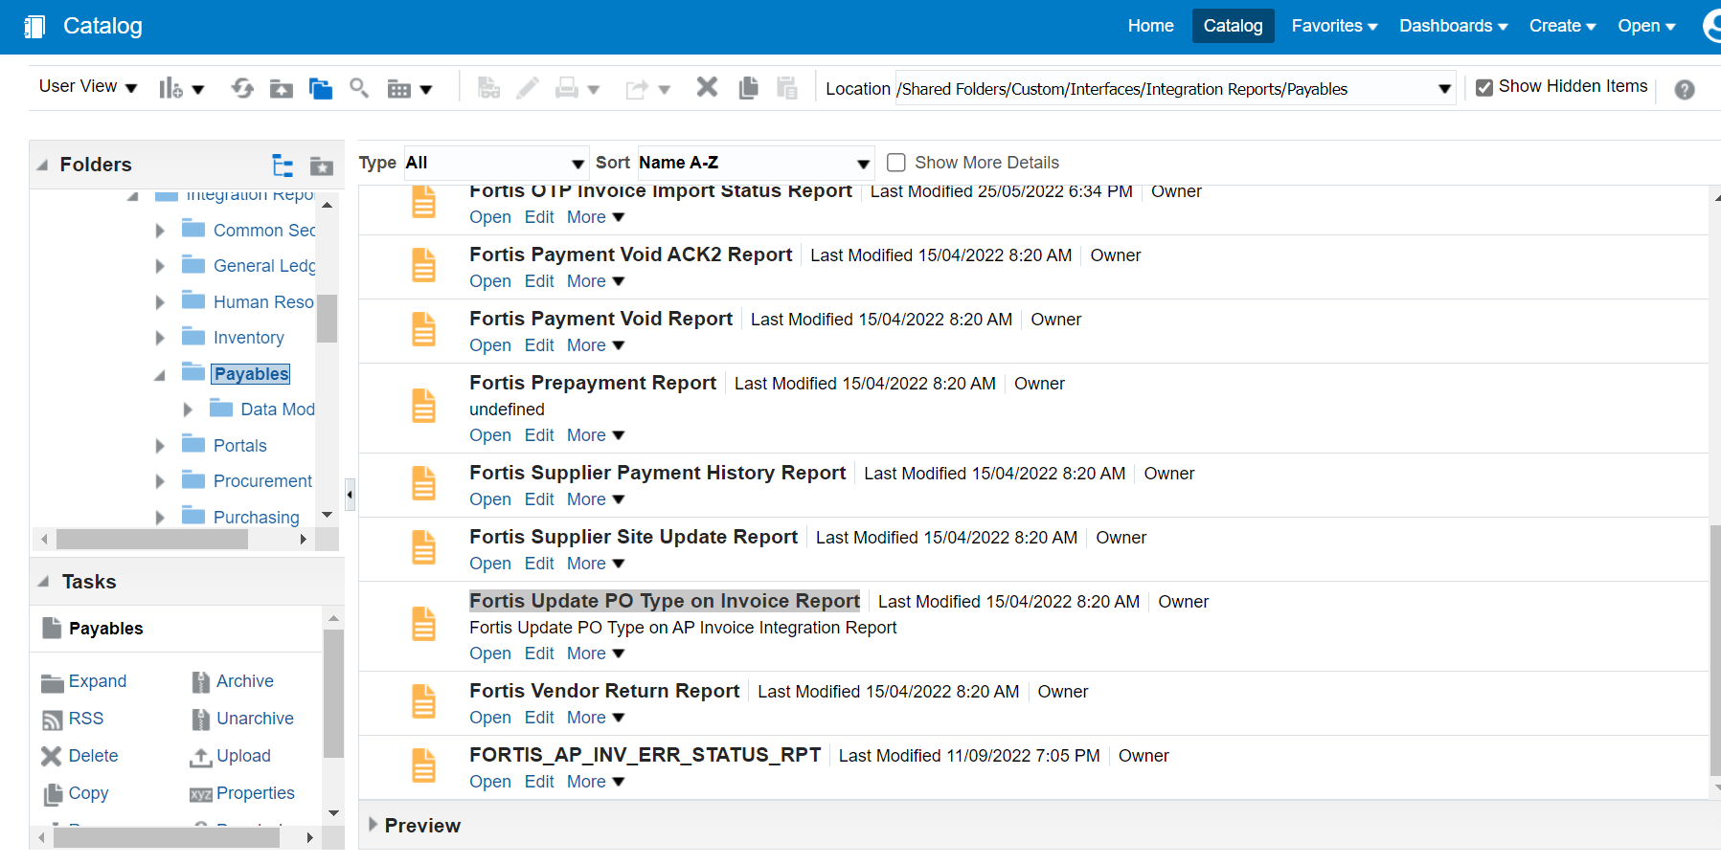

**Data Model**

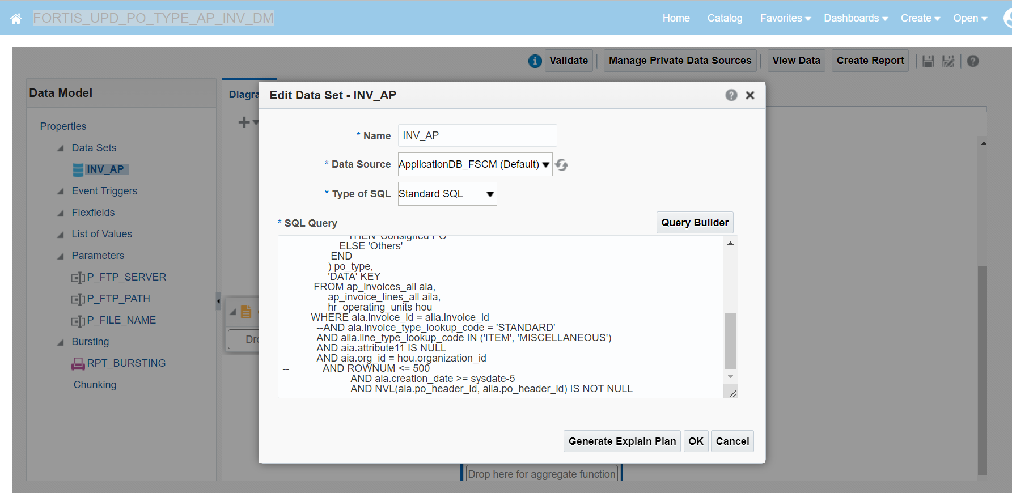

## Oracle PaaS DBCS components

This integration design does not use any DBCS related component.

## Technical flow

Following is the complete technical flow for this integration design:

1. A scheduled OIC integration (**Fortis Update PO Type at Payable Invoices (1.0)**) run every 30 mins to perform po type DFF attribute update at invoice level.
2. The OIC integration invokes BIP report Report (Fortis Update PO Type on Invoice Report.xdo) which will provide details of all the invoices for which DFF needs to be updated.
3. Using the data from above query the following operating will be performed via invoice related RSET API’s

|  |  |  |  |  |
| --- | --- | --- | --- | --- |
| Si No | Activity | Method | API URI | Type |
| 1 | Supplier Update | PATCH | /fscmRestApi/resources/11.13.18.05/suppliers/{SupplierId} | REST |
| 2 | Tax Registration | POST | /fscmRestApi/resources/11.13.18.05/taxRegistrations | REST |
| 3 | Get Tax Registration | GET | /fscmRestApi/resources/11.13.18.05/taxRegistrations/{RegistrationId} | REST |
| 4 | Update Address | SupplierAddress | /fscmService/SupplierServiceV2?WSDL  (UPDATE) | SOAP |

1. It will update invoice level DFF attribute with PO Type.

**Code Details:**



# Data FIELD Mapping

NA

## File format

NA

## Frequency

The integration is scheduled to run every 30 minutes.

# Exception handling

There can be various scenarios for an error to occur. This section defines those error scenarios, and the exception handling has been done to notify and act accordingly.

## Scenarios

In a tabular format give list of scenarios and exception handling

* If any of the step or node fails within the OIC integration, Global Fault section is configured within this OIC integration to send an OIC error notification with relevant details.
* The email id has been stored in OIC Lookup: Fortis_FaultNotification_EmailAddress_Lookup against the given OIC integration name.
* It also sends a notification whenever integration processes any data. This notification also acts as a confirmation that the integration has been running fine.

# Assumptions / Considerations

The Proposed Solution will have the following technical considerations.

In the future, if any product bug arises in functionality then this process needs to be revisited after the bug is fixed.

# Open and Closed Issues

## Open Issues

| ID | Issue | Resolution | Responsibility | Target Date | Impact Date |
| --- | --- | --- | --- | --- | --- |
|  |  |  |  |  |  |
|  |  |  |  |  |  |
|  |  |  |  |  |  |
|  |  |  |  |  |  |

## Closed Issues

| ID | Issue | Resolution | Responsibility | Target Date | Impact Date |
| --- | --- | --- | --- | --- | --- |
|  |  |  |  |  |  |
|  |  |  |  |  |  |
|  |  |  |  |  |  |
|  |  |  |  |  |  |